Exp-1:
Read an Image and Convert to Grayscale Code:
import cv2, matplotlib.pyplot as plt img = cv2.imread('image.png')
gray = cv2.cvtColor(img, cv2.COLOR_BGR2GRAY)
plt.subplot(121); plt.imshow(cv2.cvtColor(img, cv2.COLOR_BGR2RGB)); plt.axis('off') plt.subplot(122); plt.imshow(gray, cmap='gray'); plt.axis('off')
plt.show() Output:


Exp-2:
Gaussian Blur Code:
import cv2
import matplotlib.pyplot as plt img = cv2.imread('image.png')
blur = cv2.GaussianBlur(img, (5,5), 0)
plt.subplot(121); plt.imshow(cv2.cvtColor(img, cv2.COLOR_BGR2RGB)); plt.axis('off') plt.subplot(122); plt.imshow(cv2.cvtColor(blur, cv2.COLOR_BGR2RGB)); plt.axis('off') plt.show()

Output:


Exp-3:
Canny Edge Detection Code:
import cv2
import matplotlib.pyplot as plt img = cv2.imread('image.png')
edges = cv2.Canny(cv2.cvtColor(img, cv2.COLOR_BGR2GRAY),100,200) plt.subplot(121); plt.imshow(cv2.cvtColor(img, cv2.COLOR_BGR2RGB)); plt.axis('off') plt.subplot(122); plt.imshow(edges, cmap='gray'); plt.axis('off')
plt.show() Output:
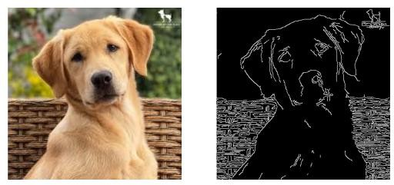

Exp-4:
Histogram Equalization Code:
import cv2
import matplotlib.pyplot as plt img = cv2.imread('image.png')
gray = cv2.cvtColor(img, cv2.COLOR_BGR2GRAY) eq = cv2.equalizeHist(gray)
plt.subplot(121); plt.imshow(gray, cmap='gray'); plt.axis('off') plt.subplot(122); plt.imshow(eq, cmap='gray'); plt.axis('off') plt.show()
Output:
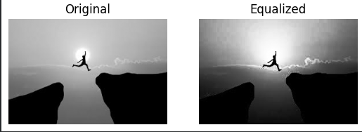

Exp-5:
Histogram Analysis Code:
import cv2
import matplotlib.pyplot as plt img = cv2.imread('image.png') colors = ('b','g','r')
for i, col in enumerate(colors):
hist = cv2.calcHist([img],[i],None,[256],[0,256]) plt.plot(hist, color=col)
plt.xlabel('Intensity') plt.ylabel('Pixels')

plt.show() Output:
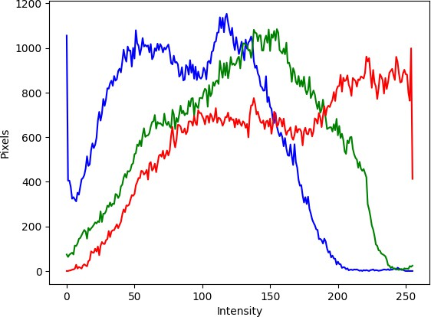

Exp-6:
Image Erosion using Erode Function Code:
import cv2
import matplotlib.pyplot as plt import numpy as np
img = cv2.imread('image.png') kernel = np.ones((5,5), np.uint8)
eroded = cv2.erode(img, kernel, iterations=1)
plt.subplot(121); plt.imshow(cv2.cvtColor(img, cv2.COLOR_BGR2RGB)); plt.axis('off') plt.subplot(122); plt.imshow(cv2.cvtColor(eroded, cv2.COLOR_BGR2RGB)); plt.axis('off') plt.show()

Output:
